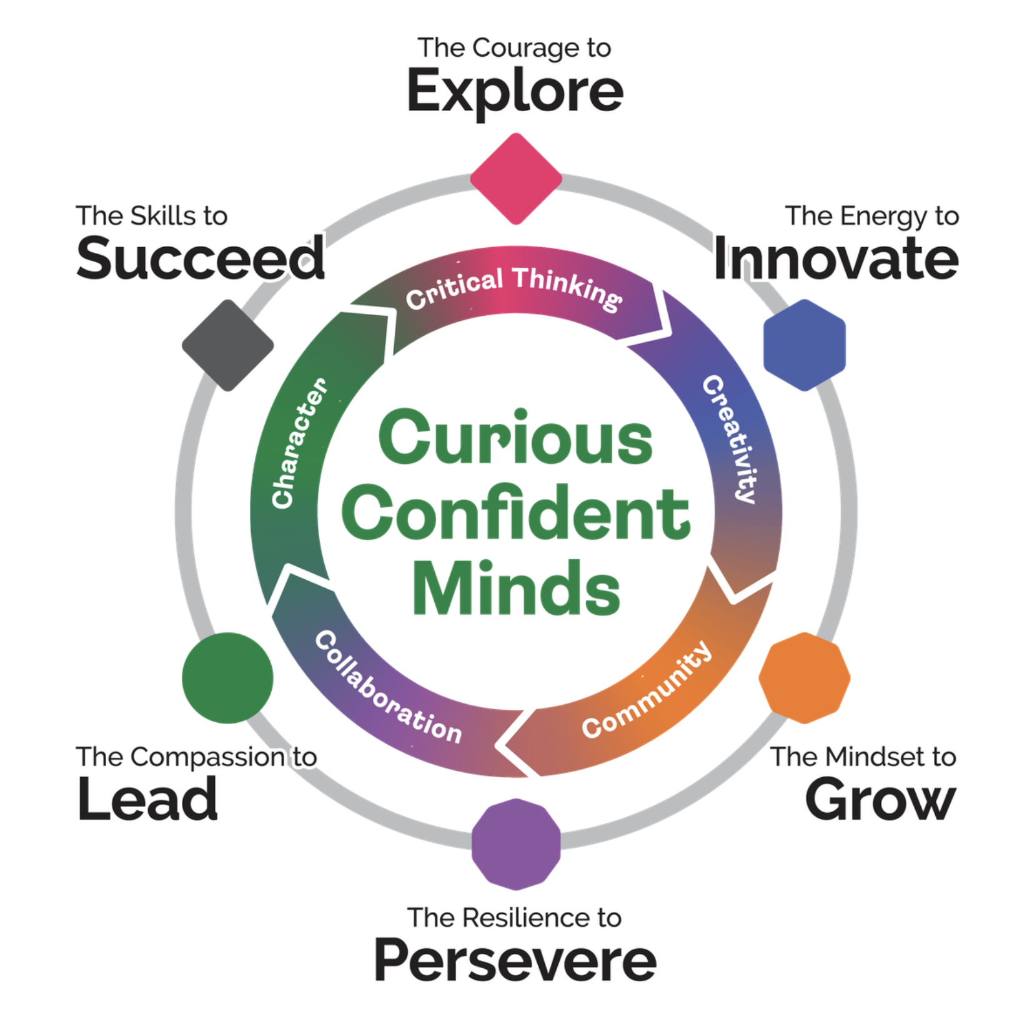
Case Study: Tenby Schools Penang
How a pioneering international school is using Purple Mash to unite two curricula and put learning at the heart of every lesson.

About Tenby Schools Penang
Tenby Schools Penang, situated in the northern part of Penang Island, Malaysia, is a dual-school community made up of an international primary school and a Malaysian national primary school, operating side by side with a shared vision: to grow the world's most curious, confident minds. Tenby Schools Penang is part of ISP (International Schools Partnership), a global network of schools.
Their mission is to deliver a transformative education that sparks curiosity and builds the self-confidence, knowledge, and life skills students need to thrive - now and throughout their lives. Underpinning that mission is a set of values the school calls the STEAM Six: the courage to explore, the energy to innovate, the mindset to grow, the resilience to persevere, the compassion to lead, and the skills to succeed. Tenby Schools Penang is also intentionally focused on ensuring students develop five key life competencies - critical thinking, community, creativity, collaboration and character - so that they are empowered to grow at the pace of change.
Central to bringing that vision to life is an ambitious 1:1 iPad programme. Every student in Years 3–6 (International) and Standards 3–6 (National) has an Apple iPad. And yet, in the corridors and classrooms of Tenby Schools Penang, you rarely hear the word 'iPad'. What you hear instead is children talking about what they're learning - a telling sign that the technology is working exactly as it should.

Bringing Two Schools Together
When Tenby Schools Penang chose to implement Purple Mash, they made a deliberate decision: every student, regardless of whether they were following the international or national curriculum, would use the same platform and the same digital tools.
"Our approach is intentionally inclusive: students in both schools use the same digital platforms and the same digital tools. As a result, collaboration and professional dialogue between teachers in our international and national schools has become far more open and connected." Mark Stone, Education Technology + Innovation Leader.

Rolling Out Purple Mash: Trust First, Training Second
When Purple Mash was first introduced to staff, the school took an approach that might seem unconventional: they gave teachers access and simply asked them to explore. No formal training. No rigid rollout. Just time and space to discover what the platform could do. The feedback was immediate and enthusiastic. Senior primary leaders and class teachers were genuinely excited by Purple Mash and the immediate impact it would have.

Support was available when needed. 2Simple staff were on hand to work with teachers one-to-one and with year groups as they planned units of work. What made the rollout work, though, was something simpler than any training session.

"Purple Mash is intuitive. Easy to use. Not complex. 2Simple." Mark Stone, Education Technology + Innovation Leader.

At Tenby Schools Penang, staff now talk confidently about differentiated and personalised learning, using Purple Mash as the vehicle.

Purple Mash in Action: What Pupils Are Doing Every Day
Teachers are always the gamechangers. Technology simply helps great teachers do extraordinary things.
Ask the teachers at Tenby Schools Penang how Purple Mash is being used, and the answer is: extensively. Across year groups and subject areas, students are using the platform's tools not as an add-on to their learning, but as a core part of how they think, create, and communicate.
Years 3 & 4
"In Year 4, we use Purple Mash every day to make learning exciting and creative. In English, we plan our ideas with 2Connect, bring them to life in 2Publish Plus, and design our own storybooks using 2Create a Story, while sharpening our grammar with the Text Toolkit. In Maths, we practise times tables with Monster Multiplication, explore data in 2Investigate, and experiment with basic formulas in 2Calculate. In Science and topic lessons, we create fact files, design quizzes in 2Quiz, and build historical timelines with 2Connect." Ms Sharmilah, Year 3–4 Leader
Years 5 & 6
"In Years 5 and 6, we take our learning even further. In English, we plan, blog, and publish our work using 2Blog and 2Publish Plus, and create ambitious multi-chapter projects with 2Create a Story. In Maths, we analyse data in depth with 2Investigate and tackle complex formulas in 2Calculate. In Computing, we code our own programs with 2Code and design 3D models with 2Design and 2Make. Purple Mash helps us think, create, and share like never before." Ms Priya, Year 5–6 Leader

The breadth of use speaks for itself and is a direct reflection of what happens when a platform is genuinely embedded rather than merely adopted.
Advice for Schools Introducing Purple Mash
When asked what they'd say to other schools considering Purple Mash, Tenby Schools Penang's leadership offered practical guidance.
- Their starting point: Before anything else, be clear on what you want learning to look like in your school and consider how students will actually access the platform day to day. Make sure it's the right fit.
- Practical questions: like whether your Wi-Fi can support school-wide use. Purple Mash is browser based and every device requires a consistent Wi-Fi connection.
- Beyond the logistics, the advice is to trust the platform and trust your teachers. Give staff the space to explore before committing to formal training. Let curiosity lead. The engagement tends to follow.
Want to see what Purple Mash could do in your school?
Learn more about Purple Mash at 2simple.com/purple-mash

